PR3: Optimalization of an RTS

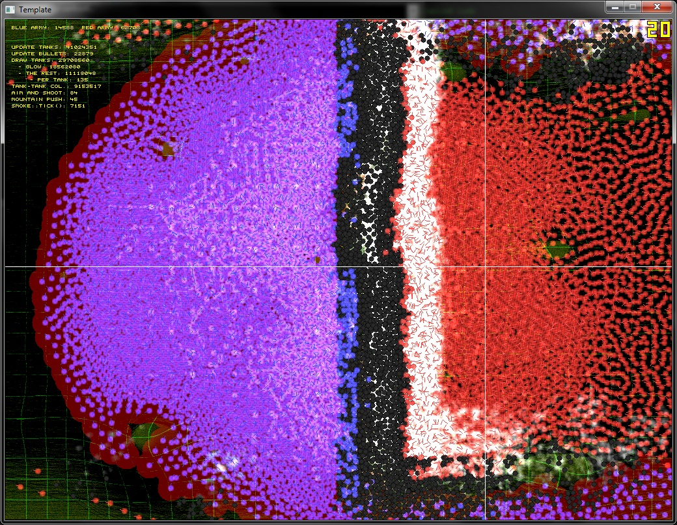

Eric Polman

130048

1GA-4PR

FGA1.PR3-02

9th of April, 2014

# Table of Contents

Table of Contents 2

# Analysis

# Measuring

# High-Level Optimizations

# Low-Level Optimizations

# SIMD Optimizations